THE PRIMARY PLANET
Teacher Resource Pack
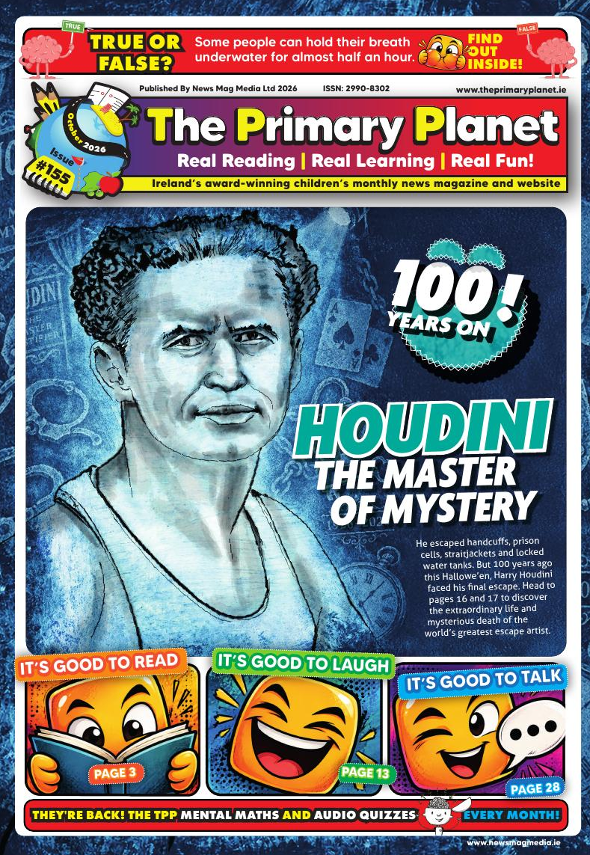
October 2026
Issue #155

TPP Mental Maths &
Audio Quiz
A new Mental Maths Challenge and General Knowledge Audio Quiz every month.
www.newsmagmedia.ie
www.theprimaryplanet.ie

Visual Arts: Build Your Own Maman
Inspired by: Louise Bourgeois's Maman
TPP location: Planet Art – page 12
Class level: 5th and 6th Class
Time: 60 minutes, plus drying time
Curriculum area: Visual Arts. Construction, form, balance and responding to art

Curriculum link
Pupils explore form, structure and balance through construction, and respond to the work of an artist from the wider world.
Learning intention
To build a free-standing sculpture that carries an idea, and to explain the thinking behind it.
You will need
– pipe cleaners or garden wire for the legs (eight per pupil)
– newspaper, masking tape and a small cardboard base
– tin foil, air-dry clay or papier-mâché for the body
– a small net or mesh bag, and marbles, beads or small stones for the eggs
Activity
1. Look at Maman on page 12. It stands over nine metres tall and holds a sac of marble eggs underneath it. Ask the class what they notice first, and how they would feel standing under it.
2. Read the section explaining why Bourgeois chose a spider for her mother: patient, clever, a weaver, a protector – and a predator too.
3. Each pupil builds a spider that stands on its own eight legs, high enough for something to sit underneath it. The body can be foil, clay or crumpled newspaper and tape.
4. Underneath, they hang or place something the sculpture is protecting. It does not have to be eggs.
5. Each sculpture is named after a person the pupil admires, as Bourgeois named hers for her mother.
Look, think and talk
– Does your sculpture stand up on its own? What did you change to make it balance?
– Bourgeois made her spider enormous. Would yours work at nine metres tall?
– Is a spider a strange choice to represent somebody you love?
– Is Maman your idea of great art? Give a reason either way.
Teacher tip
Photograph each finished sculpture from underneath, looking up through the legs. That is the view Tate Modern visitors get, and it changes how the work feels.

History: Eleven Months
Inspired by: The Irish Civil War
TPP location: Our Island's History – page 8
Class level: 5th and 6th Class
Time: 45–60 minutes
Curriculum area: Social and Environmental Education – History. Time, chronology and evidence

Curriculum link
Pupils sequence events from the past, place them within a historical framework and examine cause and consequence.
Learning intention
To order the main events of the Irish Civil War and to explain what caused the split that started it.
You will need
– Our Island's History, page 8
– one set of Civil War cards per group (provided on the next page)
– scissors, A3 paper and glue
Activity
1. Divide the class into groups of three or four and give each group a shuffled set of cards.
2. Without looking at the article, groups arrange the cards into the order they think is right.
3. They then read the article, check their decisions and change what needs changing.
4. Once agreed, they stick the cards down as a timeline and mark the point where the fighting starts and the point where it ends.
Talking points
– The Treaty split people who had fought on the same side a year earlier. What was the disagreement about?
– The Free State came into existence in December 1922, while the fighting was still going on. What does that tell you about the year?
– There was no formal surrender at the end. Why might that matter afterwards?
Teacher tip
Two of the cards carry no date. Groups have to work out where they belong from the order of events rather than from the card itself, which is where most of the thinking happens.

Civil War Timeline Cards
Cut out the cards, shuffle them and arrange them in the correct order.
January 1922  Dáil Éireann ratifies the Anglo-Irish Treaty. The republican movement splits into pro-Treaty and anti-Treaty sides. | April 1922  Anti-Treaty forces led by Rory O'Connor occupy the Four Courts in Dublin.
June 28, 1922  After a two-month stand-off, the National Army attacks the Four Courts. The Civil War begins. | August 1922  Government forces, supplied with British artillery and armoured vehicles, capture most of the towns and cities held by the anti-Treaty side.
August 22, 1922  Michael Collins is shot and killed in an ambush at Béal na Bláth, Co. Cork. Hundreds of thousands line the streets of Dublin for his funeral. | No date given  Having lost the main towns, the anti-Treaty IRA turns to guerrilla warfare, using small mobile groups called 'flying columns'.
December 6, 1922  The Irish Free State officially comes into existence, while the war is still being fought. | No date given  Nine republican prisoners are tied to a mine at Ballyseedy Cross in Co. Kerry. Eight are killed and only Stephen Fuller survives.
April 1923  Liam Lynch, military leader of the anti-Treaty side, is fatally wounded in Co. Tipperary. Several senior figures are captured. | April 30 and May 24, 1923  Frank Aiken calls a ceasefire, then orders anti-Treaty fighters to 'dump arms'. There is no formal surrender.

Writing: The Ig Nobel Prize
Inspired by: WWW News and the TPP Ig Nobel archive
TPP location: WWW News – page 13
Class level: 5th and 6th Class
Time: 45–60 minutes
Curriculum area: Language – English. Writing for a purpose; STEM – Nature of STEM

Curriculum link
Pupils write in a specific form for a real audience, and consider how scientific research is reported and why it matters.
Learning intention
To invent a piece of research that makes you laugh, then think, and to write it up as a prize citation.
Background
The Ig Nobel Prizes were founded in 1991 by Marc Abrahams and the magazine Annals of Improbable Research. They are awarded for research that makes people laugh, then think. The name plays on the word ignoble, but the prizes are not there to mock science.
This year’s winners, on page 13, included the discovery that cockroach milk holds three times the energy of cows’ milk, a study of the aerodynamics of nose-blowing, and an experiment in which 1,000 pairs of underpants were buried in more than 25 countries to see what the soil did to them. One study found that wealthy people took more sweets from a jar meant for children.
Past winners have included a team who found that people make better decisions when they badly need the toilet, and researchers who turned dead spiders into gripping tools.
Activity
1. Read about the three winners on page 13. For each one, ask the class what made them laugh, and then what it makes them think about.
2. In pairs, pupils invent a piece of research nobody has done yet. The rule is that it must be funny and it must be testable.
3. They write the citation: who won it, where they are from, what the study was about, the funny part, and the science behind it. Use the same five headings as the magazine.
4. Each pair gives a 24-second talk explaining their research, then sums it up in seven words, exactly as the real winners have to at the ceremony.
5. The class votes on which one best fits the rule: laugh first, think second.
Teacher tip
The seven-word summary is the hardest part and the most useful. Insisting on exactly seven words forces pupils to decide what their idea is actually about.

English: The Master of Mystery
Inspired by: Houdini: 100 Years On
TPP location: Houdini 100 Special – pages 16 and 17
Class level: 5th and 6th Class
Time: 40 minutes
Curriculum area: Language – English. Reading comprehension, retrieval and inference

Read both pages, then answer in full sentences.
1. What was Harry Houdini’s name at birth, and where was he born?

2. Houdini claimed Appleton, Wisconsin as his birthplace for most of his life. The article suggests a reason. What is it?

3. Explain, in your own words, why newspapers liked reporting on his police-cell escapes.

4. Houdini presented the Water Torture Cell as a short play. What did that allow him to do, and why did it matter?

5. Houdini and Sir Arthur Conan Doyle fell out. What did each of them believe?

6. Set out the events between October 19 and October 31, 1926, in order.

The Master of Mystery
Questions 7 to 8.
7. Doctors at the time believed the punches caused Houdini’s burst appendix. The article says the connection is now disputed. What evidence would you want before deciding?

8. Bess held a séance every Hallowe’en for ten years, then stopped, saying ten years was long enough to wait for any man. What do you make of that?

Design the Escape
Houdini wanted audiences to believe an escape was impossible, right up to the moment he walked out safely. Invent one of your own. There is only one rule, and it is his rule: whatever you come up with must have a natural explanation.
The name of your act | What you are locked into

How long the curtain stays closed | What the audience is looking at instead

The natural explanation. How is it actually done?

Music: The Musical Alphabet
Inspired by: Planet Music
TPP location: Planet Music – page 25
Class level: 5th and 6th Class
Time: 45–60 minutes
Curriculum area: Arts Education – Music. Listening and responding; performing

Objective
By the end of the lesson pupils will know which seven letters make up the musical alphabet and understand how it works. They will recognise the sound of an ascending and a descending scale, and be able to put the notes of a mixed-up scale back in order.
You will need
– a set of chime bars from A to A'. Also have a set from C to C' for the game, as a major scale sounds more pleasant on the ear
– a diagram of the piano keyboard, and a blank one for each pupil
Lesson
1. Write the alphabet on the board. Ask who knows which of these letters make up the musical alphabet. Rub out the rest and leave A B C D E F G. Get the class to say it forwards, then backwards.
2. Play the notes from A up to A' on the chime bars so pupils hear the notes rising, then come back down so they hear them falling in pitch.
3. Show the keyboard diagram and where the notes sit. Give each pupil a blank diagram to fill in themselves.
Game
– Put the class into teams of eight. Some pupils may get two goes.
– The first team comes to the front, turns their backs to the class, and the rest of the class closes their eyes.
– Give each team member a chime bar from C to C' with a beater, out of order.
– The class opens their eyes. The team keeps their backs turned and the bars hidden, because chime bars get shorter as they get higher and children spot that quickly. One by one the team play their bars, and it will sound odd.
– The class works out the order, starting with the lowest and the highest. They can ask team members to swap places and to play again until they are happy. Time how long it takes. It should get quicker with practice.
To finish: the musical alphabet relay
– Clear a path between the back wall and the board and divide the class into smaller teams.
– All teams start together. The first pupil runs up and writes 'A', the next 'B', and so on up to 'A' again after 'G'. The next writes 'G', because the scale is now descending.
– If somebody makes a mistake, the next pupil in that team uses their turn to correct it.
– The winning team is the first to get A B C D E F G A G F E D C B A on the board with no mistakes.

Fill in the Blanks
Read through the Word Bank first and make sure you understand every word. Then read the article, and think about the best place for each word rather than the first place.
The Master of Mystery
appendix | handcuffs | escape
Hallowe’en | mediums | Budapest
séance | straitjackets | Bess

Harry Houdini was not born Harry Houdini at all. His real name was Erik Weisz, and he was born in ______________, Hungary, in 1874. When he was four, his family emigrated to the United States and settled in Appleton, Wisconsin.
In 1899, the theatre manager Martin Beck watched him break free from a pair of ______________ and advised him to build his whole act around ______________. Houdini began challenging police officers to lock him in their strongest cells, and the newspapers loved it. He almost always emerged smiling, sometimes wearing the cuffs like bracelets.
He was suspended upside down from cranes in ______________, climbed into an oversized milk can filled with water and had its lid padlocked shut, and escaped from packing cases lowered into rivers.
After the First World War, Houdini turned against fake ______________, who claimed they could contact the dead. He and his wife, ______________, agreed a secret message that either of them would try to send if they died first. Houdini died on ______________ 1926, aged 52, after surgeons found that his ______________ had burst.
Pair Them Up
These words do not often turn up together. Write one sentence for each pair, using both words.
1. handcuffs + Hallowe’en

2. mediums + escape

3. Your own pair: ____________ + ____________

Going further. One Word Bank word was never needed. Find it and use it in a sentence of your own.

Fill in the Blanks
Read through the Word Bank first and make sure you understand every word. Then read the article, and think about the best place for each word rather than the first place.
Save the Axolotl
Minecraft | albino | habitat
metamorphosis | refuges | Xochimilco
gills | regeneration | salamanders

Axolotls are ______________, a kind of amphibian. Like frogs, they begin life in water and go through a change called ______________ to become adults. Axolotls do not. They keep their feathery ______________ and stay in the water for their whole lives, gulping air at the surface with small lungs.
Their most remarkable ability is ______________. If an axolotl loses a leg or its tail, it simply grows a new one, and it can even repair parts of its eyes and brain.
Wild axolotls are dark grey, brown or black with speckles, but the pale pink, red-eyed ______________ ones are the ones most people know, because those are the ones bred for the pet trade.
They are found in only one place on Earth: Lake ______________ and its canals in the south of Mexico City, where as few as 50 adults may be left in the wild. The main threat to them is ______________ loss. Ecologists are now building safe, clean wetland ______________ for them, breeding axolotls and releasing them back in.
Three in a Row
Write one sentence using all three words. Then do it again with the next set.
1. salamanders + metamorphosis + gills

2. Xochimilco + habitat + refuges

3. Your own three: ____________ + ____________ + ____________

Going further. One Word Bank word was never needed. Find it and use it in a sentence of your own.

All the Mistakes
Read through each article taken from this month's issue and see if you can spot the nine spelling mistakes in each.
New World Map
Take a look at a world map. Which looks bigger – Africa or Greenland? The answer might suprise you. Africa is actually about 14 times larger.
So why doesn’t it look that way? The map most of us are famillier with is the Mercator map, desined in 1569 by the Flemish cartographer Gerardus Mercator to help sailers navigate the world.
The problem is that Earth is a globe. Representing its curved surfase on a flat map causes distorsion. On the Mercator map, areas near the poles apear much larger than they really are.
In 2018, a group of cartographers created an equal-area map called the Equal Earth projection. Last month, the United Nations adopted a resolucion encouraging governments and schools to use equal-area maps when the relative sizes of continents matter. A total of 164 nations voted in favour. Six countrys abstained.
1. | 2. | 3.
4. | 5. | 6.
7. | 8. | 9.

Record-Breaking Curator
American Anderson Taylor has turned a dream into realitty – by starting his own natural history musium at only nine years of age.
The Cambridge Natural History Museum, in the villiage of Cambridge, Illinois, opened in 2024. Anderson was nine years and 340 days old, earning him a Guinness World Record as the world’s youngest male curater.
The museum began with a single display case of fosils. It has grown over the past two years and now holds 13 displays containing fossils, minerals, Native American artefacts and taxidermy specimins.
Now aged 11, Anderson fits his museum duties around school. He advertises its oppening hours online and gives talks to local groups. He and his parents have raised more than $20,000, which allowed them to buy the building as a permanant home. When he is older, he also wants to explore other areas of sceince.
1. | 2. | 3.
4. | 5. | 6.
7. | 8. | 9.

Word Workout
Go to the page, fact or story shown, then find the word that matches each clue. The number of letters and the starting letter are in brackets.
Page | Article / Paragraph | Clue
3 | The Big Story | The typical value found by adding and dividing (7, a)
4 | National News | Made to feel singled out or ashamed (11, s)
5 | National News | Needing immediate action (9, e)
6 | International News | A person who makes maps (12, c)
7 | International News | The person who looks after a museum collection (7, c)
8 | Our Island's History | Fighting by small, fast-moving groups (9, g)
9 | History's Mysteries | Equipment that finds objects underwater using sound (5, s)
10 | Media Matters | Open, and easy to see into or understand (11, t)
11 | Media Matters | People whose job is to check that rules are followed (10, r)
12 | Planet Art | An extreme fear of spiders (13, a)
13 | WWW News | The very first of its kind (9, i)
14 | Planet Farming | Brought back to its original condition (8, r)
15 | Planet Motors | Material that blocks harmful radiation (9, s)
16 | Houdini 100 | Public attention, and the work of attracting it (9, p)
17 | Houdini 100 | Drawing attention away from what really matters (12, m)
18 | Space Week Special | A strong, light metal often used in spacecraft (8, t)
19 | Space Week Special | Something built to remember people who have died (8, m)
20 | Animal SOS | Growing back a body part that has been lost (12, r)
21 | Planet Maths | To sweat (8, p)
22 | Planet STEM | Meat-eating (11, c)
23 | County by County | Small rounded hills left behind by glaciers (8, d)
25 | Planet Music | The gap between two notes with the same letter name (6, o)
28 | Planet YOU | Things that stop you paying attention (12, d)
31 | Planet Soccer | Moved down into a lower division (9, r)

Write your answers here
1. | 2. | 3. | 4.
5. | 6. | 7. | 8.
9. | 10. | 11. | 12.
13. | 14. | 15. | 16.
17. | 18. | 19. | 20.
21. | 22. | 23. | 24.

Quiz 32
This month's 32-question quiz is based on the 32 pages of The Primary Planet. The question number corresponds to the page it is taken from, so the answer to Q.7 is on page 7 and the answer to Q.21 is on page 21.
1. According to the cover, is it true or false that some people can hold their breath underwater for almost half an hour? | 17. Which Irish magician escaped from a straitjacket above Waterford’s Winterval festival?
2. During which week does the Editor suggest tackling the Soccer Maths Time quiz? | 18. How tall is the Yuri Gagarin monument in Moscow?
3. What was Ireland’s average reading score in the PISA 2025 study? | 19. Who became the first woman in space, in 1963?
4. On what date is Budget 2027 due to be announced? | 20. Which lake is the only place wild axolotls are found?
5. How many people were in emergency accommodation in Ireland in August 2026? | 21. What is the title of this month’s Maths Story?
6. Roughly how many times larger than Greenland is Africa? | 22. Which small yellow-flowered plant have scientists confirmed is carnivorous?
7. How old was Anderson Taylor when his museum opened? | 23. What is the highest point in County Down?
8. Where was Michael Collins ambushed and killed in August 1922? | 24. How many shortbread fingers does this month’s recipe make?
9. What kind of DNA turned up almost everywhere in Loch Ness? | 25. Which two films won Hans Zimmer his Oscars?
10. What age must you be to sign up for a video-sharing platform like TikTok, YouTube or Instagram? | 26. Who reviewed The Wild Robot?
11. In what year was Coimisiún na Meán created? | 27. What is the theme of the November writing challenge?
12. What does Maman mean in French? | 28. On what date is World Mental Health Day marked?
13. How many people performed the Vulcan salute at the Science Museum in London? | 29. Which two provinces meet at the Aviva Stadium on October 24?
14. Where were the 2026 National Ploughing Championships held? | 30. How many league titles have Manchester City won?
15. How long does the Rimac Nevera R take to reach 100 km/h? | 31. How many Premier League goals did Robbie Keane score?
16. What was Harry Houdini’s real name? | 32. Which club has Katie Keane just signed a three-year contract with?

What's in the News?
How well have you read this month's issue? As well as testing your memory and retention, this page tests your imagination. We base it on our news pages. Read the articles and answer the following questions.
1. Read ‘No More Goujons?’ What would the proposed cold lunch include?

2. Read ‘What People Want’. What was the top priority in the poll, and what percentage chose it?

3. Read ‘Still Homeless’. What is Finland’s ‘housing-first’ policy? Should Ireland do the same? Justify your answer.

4. Read ‘New World Map’. Why does Greenland look so big on the Mercator map?

5. Read ‘AI’s Rapid Rise’. Is it time to slow AI down? Justify your answer.

6. Read ‘Record-Breaking Curator’. What does Anderson Taylor want to do when he is older?

7. Read ‘AI Actress Tilly’. Would it matter to you if the actor you were watching wasn’t human? Justify your answer.

8. What is your favourite news story in this month’s TPP? Why?

Know Your Sport
How well have you read this month's sports news? We base this activity on the pages from our sports section. Read the articles and answer the following questions.
1. Which two provinces face off at the Aviva Stadium on October 24?

2. Which club did Ronan O’Gara sign a new contract with, ending the Leinster speculation?

3. In the Ryan Cup trial, how many points will a goal be worth?

4. Name one new hurling rule being trialled at the Fitzgibbon Cup.

5. Who did Leona Maguire win both her Solheim Cup foursomes matches with?

6. Which three Dublin clubs are chasing the League of Ireland Premier Division title?

7. Who succeeded Pep Guardiola as Manchester City manager?

8. What county is Katie Keane from, and what position does she play?

Discussion Grid
Twenty short questions with no right answers. Pairs take one each and argue it out. Nothing to write down.
1. Should hot school meals be the only option, with no cold lunch? | 6. Would you watch a film starring an actor who wasn’t human? | 11. Should there be a world record for everything? | 16. Should we build monuments to animals sent into space?
2. Is reading a comic as valuable as reading a novel? | 7. Should a nine-year-old be allowed to run a museum? | 12. Should tourists be allowed to use a lift built for schoolchildren? | 17. Is it right to keep axolotls as pets?
3. Should the government spend more on housing than on cutting taxes? | 8. Can a civil war ever be settled fairly? | 13. Would you rather restore an old tractor or design a new one? | 18. Should Hallowe’en sweets always be shared out evenly?
4. Should every school switch to an equal-area world map? | 9. Is the Loch Ness case closed? | 14. Is any car worth €2.3 million? | 19. Does a monument left on the Moon belong to everybody?
5. Is it time to slow down the development of AI? | 10. Is a giant bronze spider great art? | 15. Was Houdini right to expose the fake mediums? | 20. Is listening harder than talking?

Did You Know?
Every issue of The Primary Planet is packed with facts and figures. Which four stuck with you? Write them down, add a small illustration for each, then compare your choices with the class. Here is one of ours to start you off.
In 2021 an axolotl appeared on Mexico’s 50-peso banknote, which was named Note of the Year. Around 12.9 million Mexicans are holding on to theirs, just because they love it.

1

2

3

4

Come Dine with Me
This month's issue is packed with stories about remarkable people. Imagine you are hosting a dinner party and you can invite any two of them, living or dead. Give a brief reason for each choice, then write three questions you would ask to get the conversation going.
Stuck for a guest? Try pages 7, 9, 12, 16 or 19.
Guest One
Name, and the page you found them on

Why you chose them

Three questions you would ask
1.
2.
3.
Guest Two
Name, and the page you found them on

Why you chose them

Three questions you would ask
1.
2.
3.

We Want Book Reviews
Tell us what the book is about, without giving away the ending. Give it a mark out of 10 and say what earned that mark. Name the best bit. Then tell us who else would enjoy this book, and why. Send finished reviews to schools@theprimaryplanet.ie.
Title of the book

Author

Your mark out of 10, and what earned it

What the book is about, without giving away the ending

The best bit

Who else would enjoy this book, and why

Your name, class and school:

Don’t forget!
Super-cool TPP hoodies are awarded to pupils who get their short stories or poems published in The Writing Corner.
Real reasons to write.

The Writing Corner
This month’s challenge is a Science Week special. Your story or poem must be based on the line below, must not run past 450 words, and must be your own work. No AI-generated entries. Email your entry to schools@theprimaryplanet.ie.
‘Science?’ scoffed the Mayor. ‘That’s hardly going to save us now!’

Plan it first
Who is speaking, and who are they speaking to? What has gone wrong? Who is the one person who thinks science can fix it? Decide how it ends before you start writing.

Title

Your story or poem

Continue on the back of this sheet. Name, class and school at the top, please.

Maths Story #155
Trick-or-Treat, page 21. Read the story first. Show your working in your copy.
1. The friends left home at 6:17 p.m. and returned at 8:15 p.m. How long did they spend trick-or-treating?

2. Josh estimated that his bag weighed 5 kg. When weighed, it was actually 3.852 kg. How much lighter was it than his estimate?

3. Amelia’s bag weighed 2.784 kg and Nathan’s weighed 3.129 kg. (a) What was the combined weight of all three bags? (b) What was the average weight of the bags?

4. There were 28 apples. Josh took half of them, Amelia took one-quarter and Nathan received the remainder. How many apples did each person receive?

5. There were 234 monkey nuts. Nathan received five-sixths of them and Josh received two-thirds of those remaining. Amelia received the rest. How many monkey nuts did each person receive?

6. Write the number of monkey nuts received by Nathan, Josh and Amelia as a ratio. Give your answer in its simplest form.

7. How many coins did the friends collect altogether?

8. Calculate the total value of all the coins collected.

9. The money was divided equally among the three friends. (a) How much did each person receive? (b) Each friend then donated 20% of their share to charity. How much did each person donate? (c) How much did each person have left?

10. The friends also counted 224 sweets and bars. The ratio of sweets to bars was 5:3. (a) How many sweets did they have? (b) How many bars did they have? (c) If each friend ate seven bars, how many bars remained?

11. The film began at exactly 9:58 p.m. and lasted 123 minutes. If it played without interruption, at what time and on what date did it finish?

12. How much time passed between the friends leaving home at 6:17 p.m. and the film ending?

Sports Crossword Time
How well have you read this month's sports news? Here, in Know Your Sport, we’re testing your memory and retention skills. We base this activity on the pages from our sports section. Read the articles and answer the following questions.
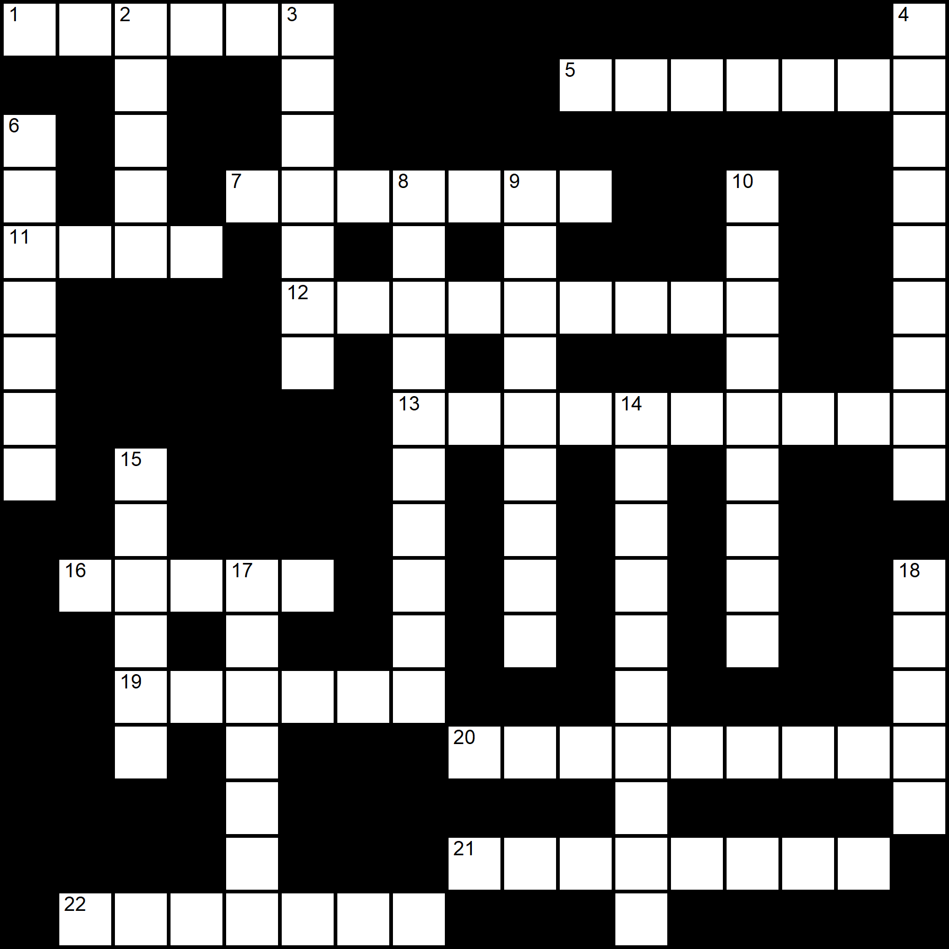
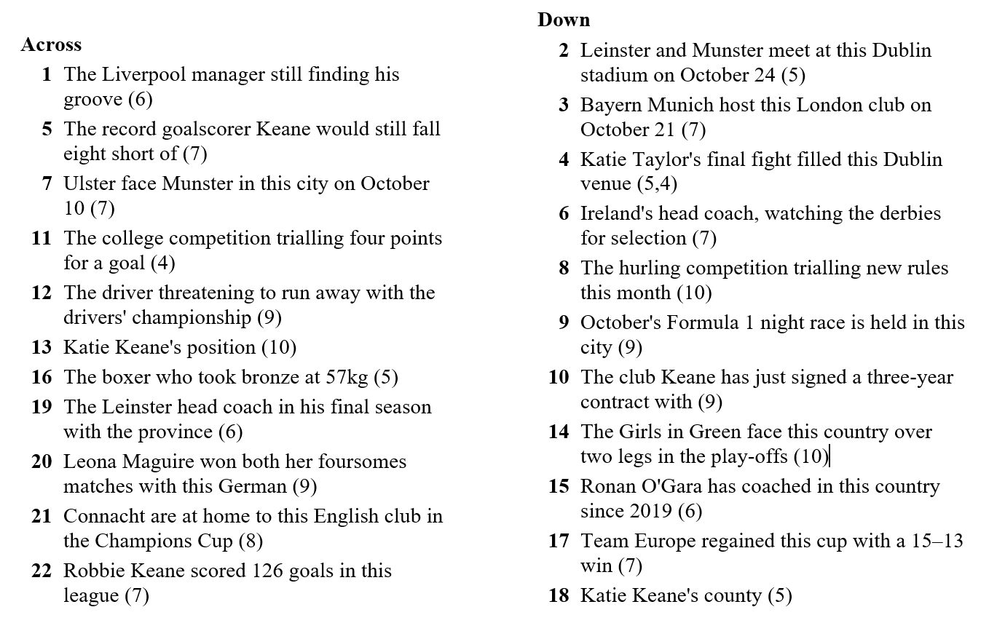
TPP Crossword Time
Think you’ve been paying attention? All the clues in this month’s crossword come straight from the pages of The Primary Planet. Every answer can be found somewhere in this issue – so sharpen your pencil, flick through the mag, and see how many you can crack!
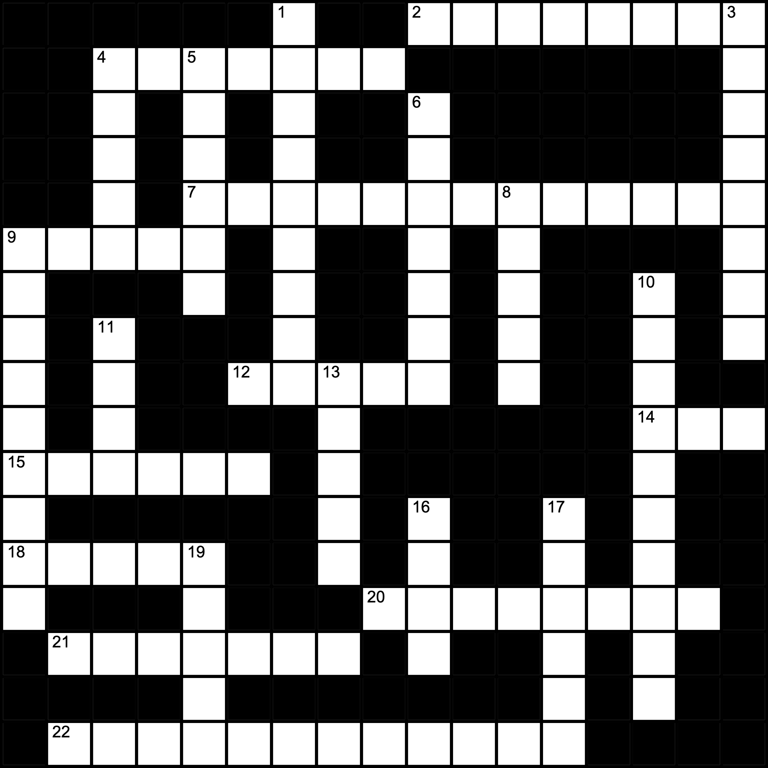

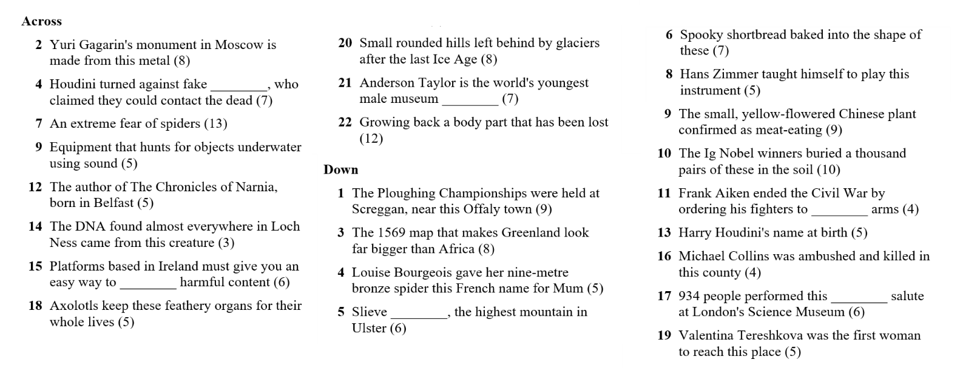
Sudoku Time
Each row, each column and each of the nine boxes must contain the numbers 1 to 9 exactly once.

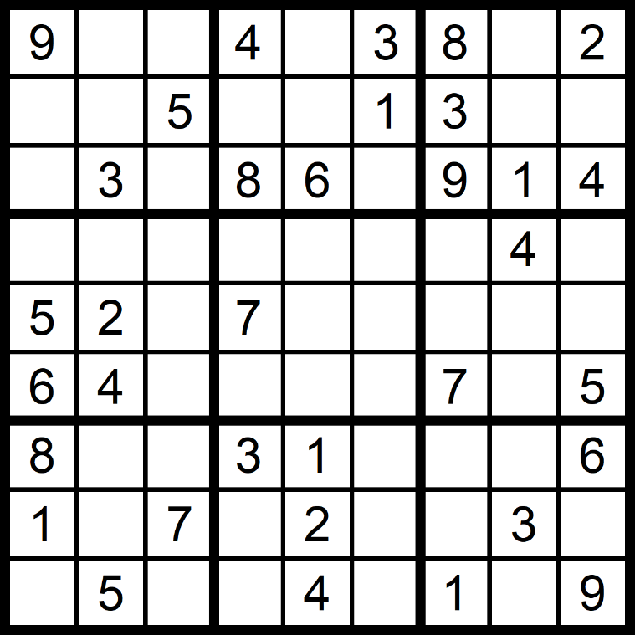

Easy
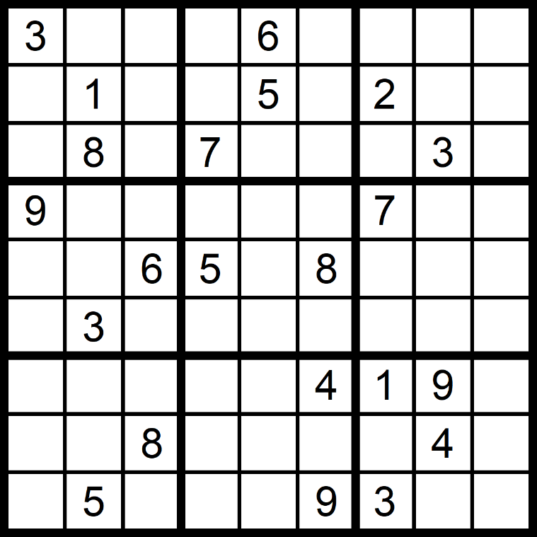

Hard

Futoshiki time
To solve a Futoshiki Puzzle you must ﬁll in the numbers (1-4 for a four-line grid). Make sure that a number appears only once on each column and row. The symbols < and > tell you if the number in each square is bigger or smaller than the number next to it.
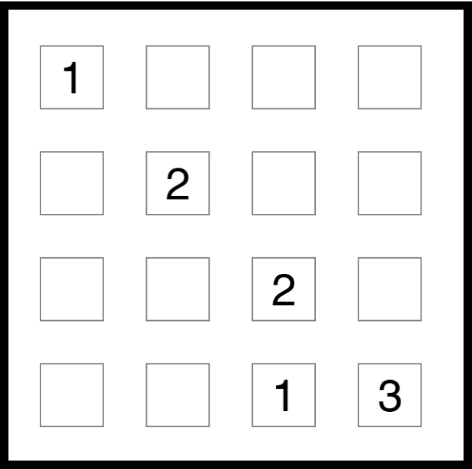

KenKen Time time
Each row and each column in a KenKen puzzle must contain the numbers 1–4. The bold cages show a target number and an operation. The numbers you place inside must make that total (in any order). You cannot repeat a number in any row or column.

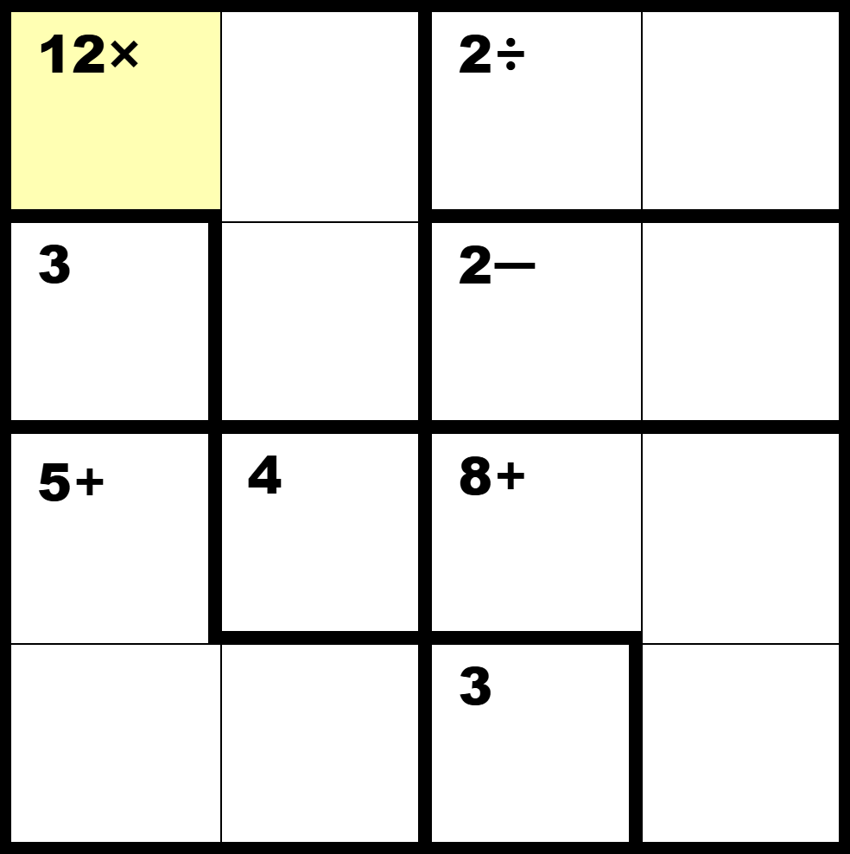

Poster Print Time
Plan it in rough first, then draw it properly in the frame.
World Space Week runs from October 4 to 10, and this year’s theme is ‘Rocket Revolution’. Pages 18 and 19 visit eight monuments to the people, animals and machines of space exploration, including one left standing on the Moon.
Design a poster for a World Space Week event in your school. Before you start, decide on these four things.
– The one image somebody will see from across the corridor
– Your headline, in six words or fewer
– The three facts a visitor needs: what, where and when
– One person, animal or machine from pages 18 and 19 worth putting on it
Planning Box

Poster Print Time

Answers
Fill in the Blanks – The Master of Mystery
Budapest, handcuffs, escape, straitjackets, mediums, Bess, Hallowe’en, appendix
Not used: séance
Fill in the Blanks – Save the Axolotl
salamanders, metamorphosis, gills, regeneration, albino, Xochimilco, habitat, refuges
Not used: Minecraft
All the Mistakes – New World Map
surprise, familiar, designed, sailors, surface, distortion, appear, resolution, countries
All the Mistakes – Record-Breaking Curator
reality, museum, village, curator, fossils, specimens, opening, permanent, science

Crack the Quote
If you think you are too small to make a difference, try sleeping with a mosquito in the room.

Word Workout
1. average 2. stigmatised 3. emergency 4. cartographer 5. curator 6. guerrilla 7. sonar 8. transparent
9. regulators 10. arachnophobia 11. inaugural 12. restored 13. shielding 14. publicity 15. misdirection 16. titanium
17. memorial 18. regeneration 19. perspire 20. carnivorous 21. drumlins 22. octave 23. distractions 24. relegated

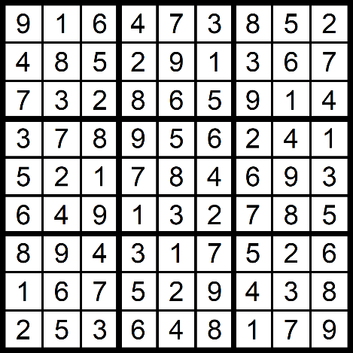
Answers Sudoku, Futoshiki, Ken-Ken
Quiz 32
1. True
2. Maths Week, October 10–18
3. 500
4. October 6
5. 17,885
6. About 14 times
7. Nine years and 340 days old
8. Béal na Bláth, Co. Cork
9. Eel DNA
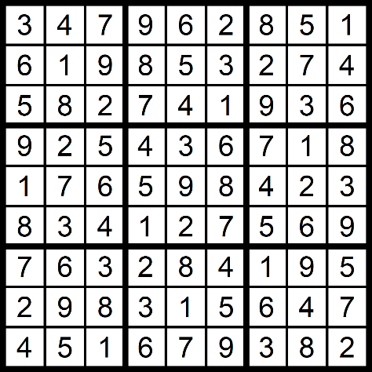
10. 13 years old
11. 2023
12. Mum
13. 934
14. Screggan, near Tullamore, Co. Offaly
15. 1.72 seconds
16. Erik Weisz
17. Keith Barry
18. 42.5 metres
19. Valentina Tereshkova
20. Lake Xochimilco, in the south of Mexico City
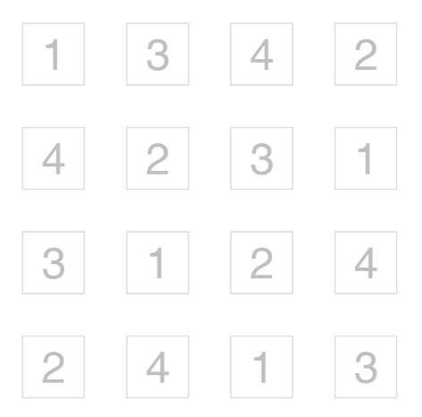
21. Trick-or-Treat
22. Saxifraga candelabrum
23. Slieve Donard, 850 m – the highest mountain in Ulster
24. 18
25. The Lion King and Dune
26. Aoibh, Co. Offaly
27. A Science Week special
28. October 10
29. Leinster and Munster
30. 10
31. 126
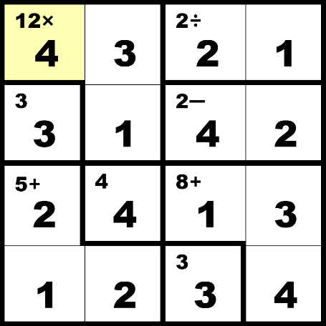
32. Leicester City

Answers
What’s in the News?
1. A wholemeal sandwich, wrap or roll, a piece of fruit and a serving of salad
2. Help with the cost of energy and home heating, chosen by 23%
3. Homeless people are given a permanent home first, and their other problems are dealt with afterwards; then pupils’ own answer
4. Earth is a globe, and flattening its curved surface stretches areas near the poles
5. Pupils’ own answer
6. Become a palaeontologist and explore other areas of science
7. Pupils’ own answer
8. Pupils’ own answer
Know Your Sport
1. Leinster and Munster
2. La Rochelle
3. Four
4. Two points for a sideline cut over the bar; puckouts must cross the 45-metre line; two or more consecutive handpasses are outlawed
5. Esther Henseleit of Germany
6. Shamrock Rovers, Bohemians and St Patrick’s Athletic
7. Enzo Maresca
8. Meath; she is a goalkeeper
Civil War Timeline Cards – correct order
January 1922 · April 1922 · June 28, 1922 · August 1922 · August 22, 1922 · guerrilla warfare · December 6, 1922 · Ballyseedy · April 1923 · April 30 and May 24, 1923

Sports Crossword TPP Crossword
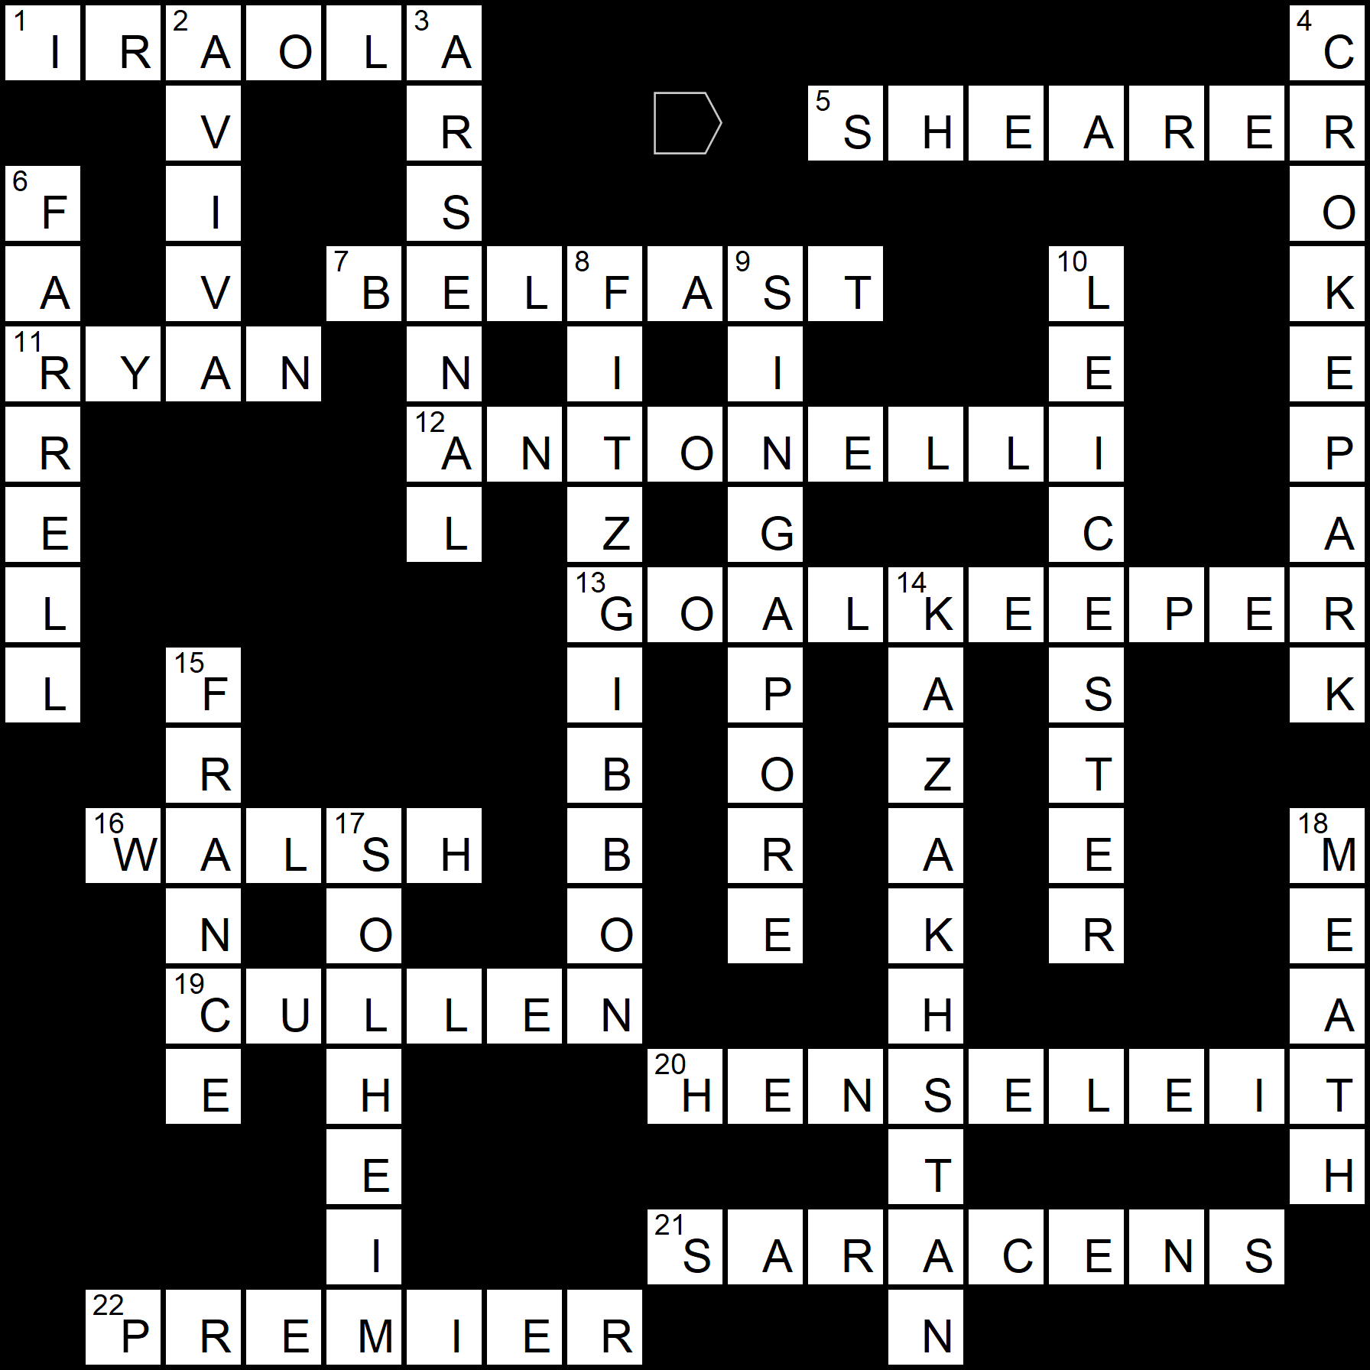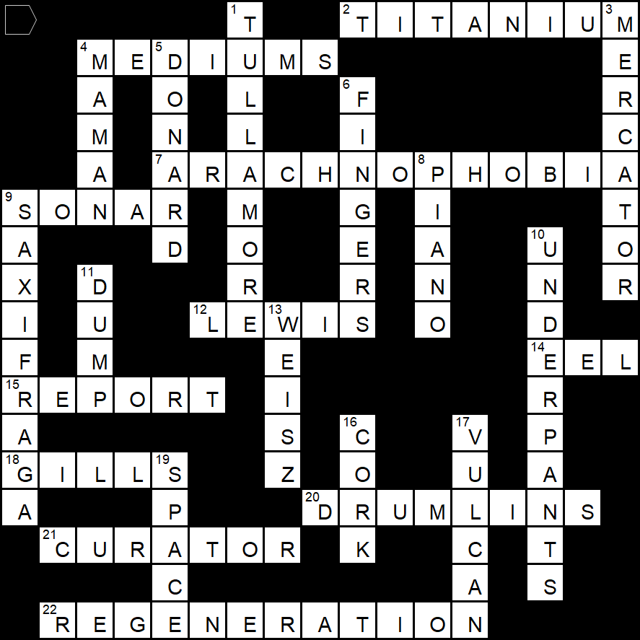

Answers
Maths Story #155 – Trick-or-Treat
1. 1 hour 58 minutes
2. 5.000 kg − 3.852 kg = 1.148 kg
3. (a) 3.852 + 2.784 + 3.129 = 9.765 kg (b) 9.765 ÷ 3 = 3.255 kg
4. Josh 14 apples, Amelia 7 apples, Nathan 7 apples
5. Nathan 195, Josh 26, Amelia 13
6. 195:26:13 = 15:2:1
7. 19 + 27 + 15 + 48 + 13 + 21 = 143 coins
8. €38.00 + €27.00 + €7.50 + €9.60 + €1.30 + €1.05 = €84.45
9. (a) €28.15 each (b) €5.63 each (c) €22.52 each
10. (a) 140 sweets (b) 84 bars (c) 21 eaten, 63 bars remaining
11. 12:01 a.m. on 1 November
12. 5 hours 44 minutes
English: The Master of Mystery
1. Erik Weisz, born in Budapest, Hungary
2. He wanted American audiences to consider him one of their own
3. Officers searched him beforehand and supplied their own restraints, so the escapes looked impossible and made a good story
4. Presenting it as a short play let him claim copyright without revealing how the apparatus worked, which stopped rivals copying it
5. Conan Doyle believed in Spiritualism and even suspected Houdini had supernatural powers; Houdini insisted everything he did had a natural explanation
6. Oct 19 lecture at McGill; Oct 22 struck by J. Gordon Whitehead; travelled to Detroit and was diagnosed with acute appendicitis; Oct 24 performed with a temperature of about 40°C and collapsed; hospital, burst appendix and peritonitis; died Oct 31
7. Pupils’ own answer. Look for a reference to the fact that appendicitis usually develops when the appendix becomes blocked and inflamed, and that cases after a blow are disputed
8. Pupils’ own answer

