NEWS FLASH
Teacher Resource Pack
October 2026
Issue #107
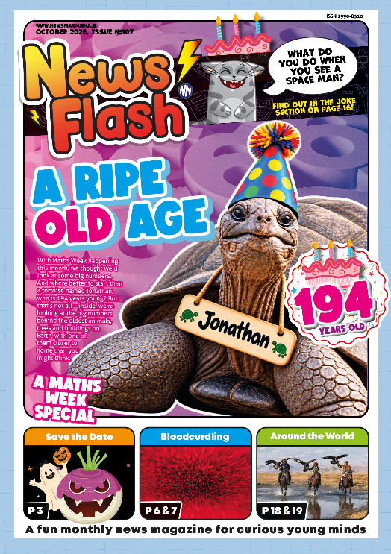

Fill in the Blanks
Read through the words in the Word Bank first and make sure you understand them. Then read the article. Think about the best place to put each word, not simply the first place it might fit. Be careful as you go, as some words may fit in more than one place while others will suit only one.
Jack-o’-Lanterns
light | smiling | turnip
scooped | lid | devil
enjoy | holes | face

Every autumn, people in many countries get ready for Hallowe’en. One of the most famous Hallowe’en decorations is the jack-o’-lantern. It is usually made from a large, round pumpkin. First, an adult carefully cuts off the pumpkin’s ______________. Then the seeds and soft flesh inside are ______________ out with a spoon.
Next comes the fun part. Children can help decide what ______________ the pumpkin should have. A simple face might have two triangular eyes, a nose and a wide, ______________ mouth. An adult should use a sharp knife to cut the design because knives can be dangerous.
When the carving is finished, a small ______________ can be placed inside the pumpkin. Traditionally, people used candles, but battery-powered lights are safer and can also make the pumpkin glow. At night, the light shines through the ______________ and makes the face look bright and spooky.
The name ‘jack-o’-lantern’ comes from an old Irish story about a man called Stingy Jack. The story says that Jack tricked the ______________ and was not allowed into heaven. He was also refused entry to hell, so he was left to wander in the dark with only a burning coal inside a ______________. Today, jack-o’-lanterns are a cheerful part of Hallowe’en celebrations and are often displayed outside homes for everyone to ______________.

All the Mistakes
Read through the article taken from this month’s issue and see if you can spot the ten spelling mistakes.
Driverless Taxis
In Austin, a city in Texas, USA, you can now order a taxi that turns up with nobody inside it.
The Cybercab, built by Tesla, carries two passangers and has no steering wheel, no pedals and … no drvier!
The car, which started picking up its first passengers last month, finds its way using cameras alone. A computer built into the car studies everything the camaras see and uses that information, or data, to stear, brake, speed up and stop.
Texas is not the only place. China has more driveless taxis than anywhere else in the world – over 20 cities use them. You can also hail one in Dubai and Abu Dhabi, and it seems countries such as Singapore, Spain, Switzland, Japan and South Korea are set to joine in.
Closer to home, though not in Ireland, driverless taxis are being tested on the streets of London right now, with the first proper service hopeed for by the end of the year.
Would you get into a taxi with nobody drivng it?
Flashy Fact
Tesla is not the only one at it. Robotaxi firm Waymo is owned by Alphabet, the company that also owns Google. China’s three big robotaxi firms are Baidu, Pony.ai and WeRdie.
Correct spelling
1. | 6.
2. | 7.
3. | 8.
4. | 9.
5. | 10.

Word Workout
Go to the page, fact or story shown, then find the word that matches each clue. The number of letters and the first letter are given in brackets.
Page | Article / Paragraph | Clue | Answer
3 | Save the Date | A dead person brought back to life (6, z)
4 | Taylor’s Bug Names | Small animals or creatures (8, c)
5 | Spiders, Spiders, Everywhere! | About, but not exactly (7, r)
6 | Picture This | A strong, hard metal (4, i)
7 | Picture This | Soft tissue inside bones (6, m)
8 | This Month in History | Given an idea to create something (8, i)
9 | Art to Heart | A particular area or part (6, r)
10 | Working in Our Community | Jerks away because of fear or pain (8, f)
11 | Mega Machines | Easy to recognise as different (11, d)
13 | A Ripe Old Age | Checked and proved to be true (8, v)
14 | Star Quality | Normal, not special or unusual (8, o)
15 | Star Quality | A young person becoming a teenager (10, a)
18 | Around the World | In a way that has continued for many years (13, t)
20 | Amazing Animals | Falling down or caving in (10, c)

Quiz 24
This month’s 24-question quiz is based on the 24 pages of News Flash. The question number corresponds to the page it is taken from. For example, the answer to Q.7 can be found on page 7 and the answer to Q.14 can be found on page 14.

1. What is the name of our cover star?

2. What can’t Flashy find?

3. What was the name of the first satellite?

4. What are Taylor Swift fans called?

5. Does Ireland have any native spiders considered dangerous to humans?

6. How many litres of blood does an adult’s body hold?

7. What do platelets help to form?

8. What was Christopher Robin’s bear originally called?

9. What is the official name of the Quakers?

10. What are the three places in Ireland where you can train to be a vet?

11. Where is the Holmer Terra Dos 5 built?

12. When do scientists believe Jonathan hatched?

13. What activity did Jeanne Calment take up when she was 85?

14. What did the Taliban order in 2008?

15. Why was Malala awarded the Nobel Peace Prize in 2014?

16. Which animals appear in the autumn picture for Eye Spy?

17. To which email should you send a good joke?

18. Where do eagle hunters gather every autumn?

19. What is the name of Mongolia’s national festival?

20. What is the shoebill’s scientific name?

21. When did Ötzi the Iceman die?

22. In which league do Fleetwood Town play?

23. What was the score in the final set of this year’s women’s US Open final?

24. How long was Bob Beamon’s record-breaking jump?

What’s in the News?
How well have you read this month’s magazine? Here in ‘What’s in the News?’, as well as testing your memory and retention skills, we also test your imagination and creative skills. This activity is based on the News Desk section on pages 4 and 5. Read the articles and answer the following questions.
1. What type of tree became a ‘poo-pee’ tree?

2. What are the secretive tree-climbing cats called?

3. In which Texan city can you order a driverless taxi?

4. Which country has more driverless taxis than anywhere else in the world?

5. What is the name of the County Sligo school where pupils saw a giant puffball mushroom?

6. What is the world’s biggest known living organism?

7. Which type of spider arrived in Ireland in the late 1990s?

8. Which type of insect was named after Oscar Piastri?

Know Your Sport
How well have you read this month’s sports news? Here, in Know Your Sport, we’re testing your memory and retention skills. This activity is based on the sports section. Read the articles and answer the following questions.
1. Who will Brighton face in the fourth round of the Carabao Cup?

2. Who do Ireland play on November 6?

3. Which Spanish team did Troy Parrott join in August?

4. How many fans watched Katie Taylor’s final professional fight at Croke Park?

5. How many European Championship titles did Katie Taylor win as an amateur?

6. Who did Elena Rybakina beat in the women’s US Open final?

7. How many All-Ireland titles have Limerick won in the past nine years?

8. How many players were nominated for TG4 All-Stars?

Crack the Joke
In this month’s Crack the Joke on page 17, a funny joke is waiting to be cracked. When you solve the code and reveal the gag, see if you can come up with an illustration that you think best captures the joke.

Colouring Time
Meet Rex the shoebill from page 20. Colour his enormous bill, shaggy feathers and swampy home. Look back at the article for ideas, or invent your own colours for the scene.
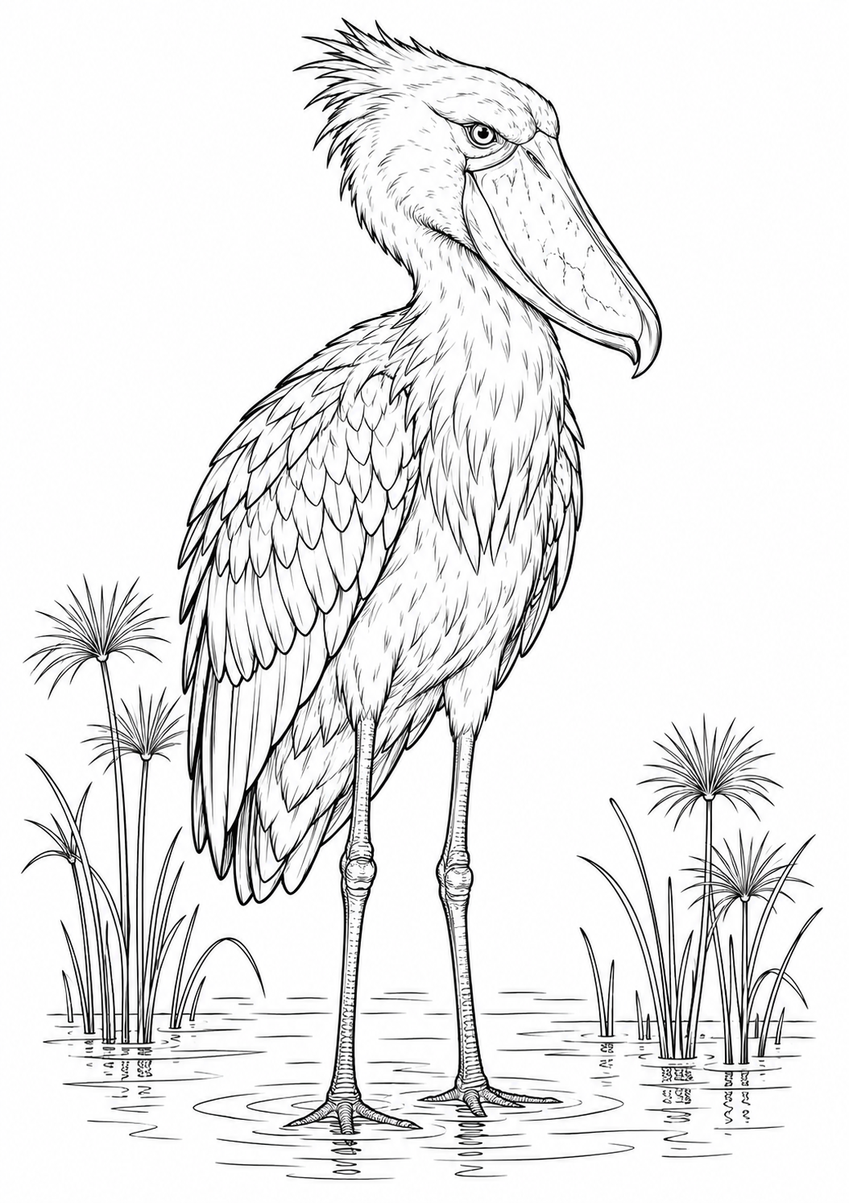

Design Your Own Cover

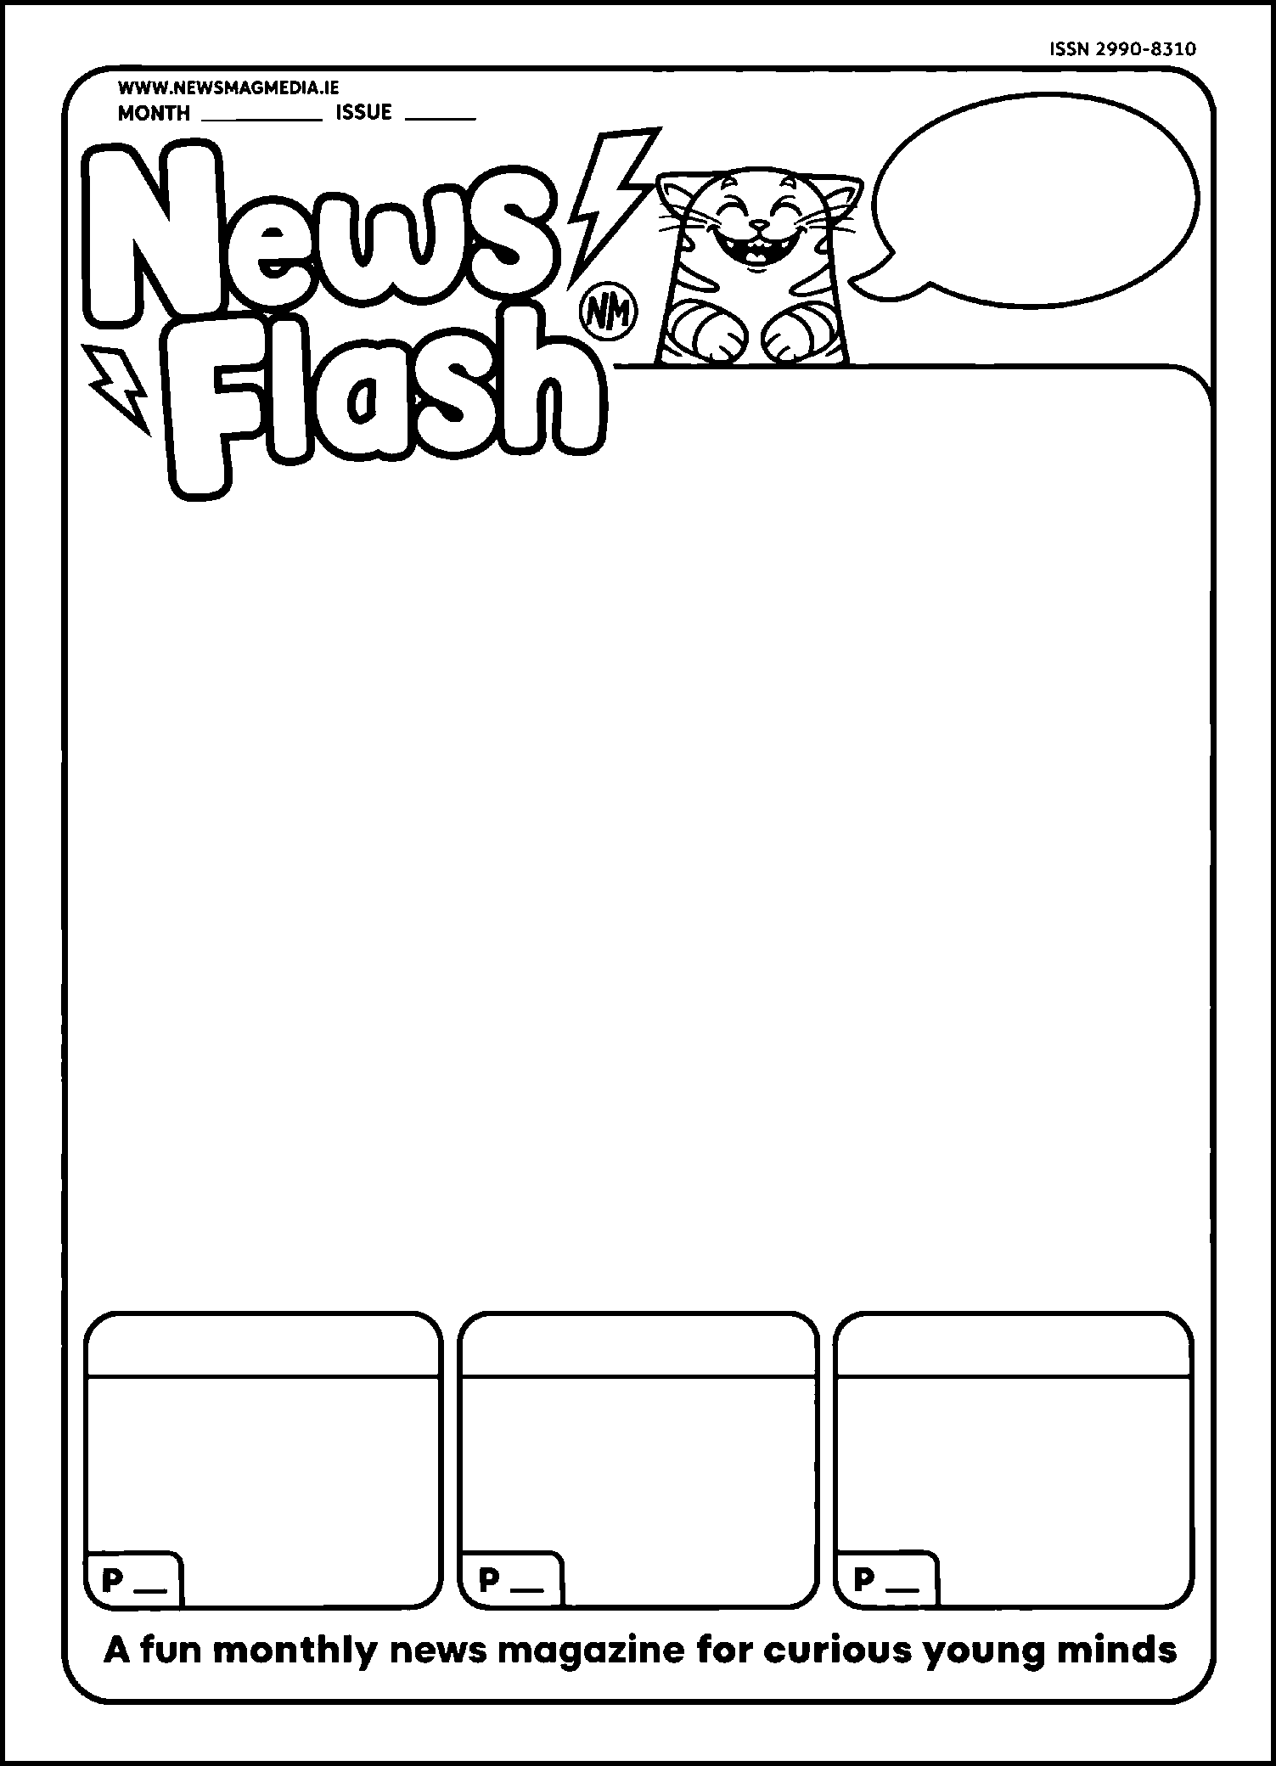

Let’s Talk About It
Some of these you will agree with straight away. Some will make you cross. That is the point. Take a side, give your reasons and listen properly to somebody who thinks the opposite. You are allowed to change your mind.
1. Hallowe’en is the worst holiday.

2. Schools should be closed on World Teachers’ Day.

3. Maths is the best subject in school.

4. There is no need to put the clocks back.

5. Winnie-the-Pooh is the best children’s character.

6. Driverless taxis are safer than taxis with drivers.

Design Your Ger
A ger is a proper family home that can be taken apart and moved. Imagine you are helping a Mongolian herding family plan the inside of one. Include places to sleep and store belongings, rugs, a stove in the middle and one modern item powered by a solar panel. Use page 18 for inspiration.

The modern item I included is

My Favourite Facts
Every issue of News Flash is packed with facts and figures. Which four stuck with you? Write them down, draw a small illustration to go with each one, then share your choices with the class and see whether anybody picked the same ones. Here is one of ours to start you off.
The world’s biggest known living organism is a honey fungus in Oregon, USA. Mostly hidden underground, it covers almost 10 square kilometres.

1

2

3

4

Word Search Maker
Build a word search for a classmate to solve. Pick 12 words from this month’s issue and hide them in the grid, running forwards, backwards, up, down or diagonally. List all 12 in the boxes underneath so your classmate knows what to hunt for. Then fill every empty square with random letters until your words disappear. To make it harder, hide one extra word that you leave off the list.



Sudoku Time
Each row, each column and each of the nine boxes must contain the numbers 1 to 9 exactly once.

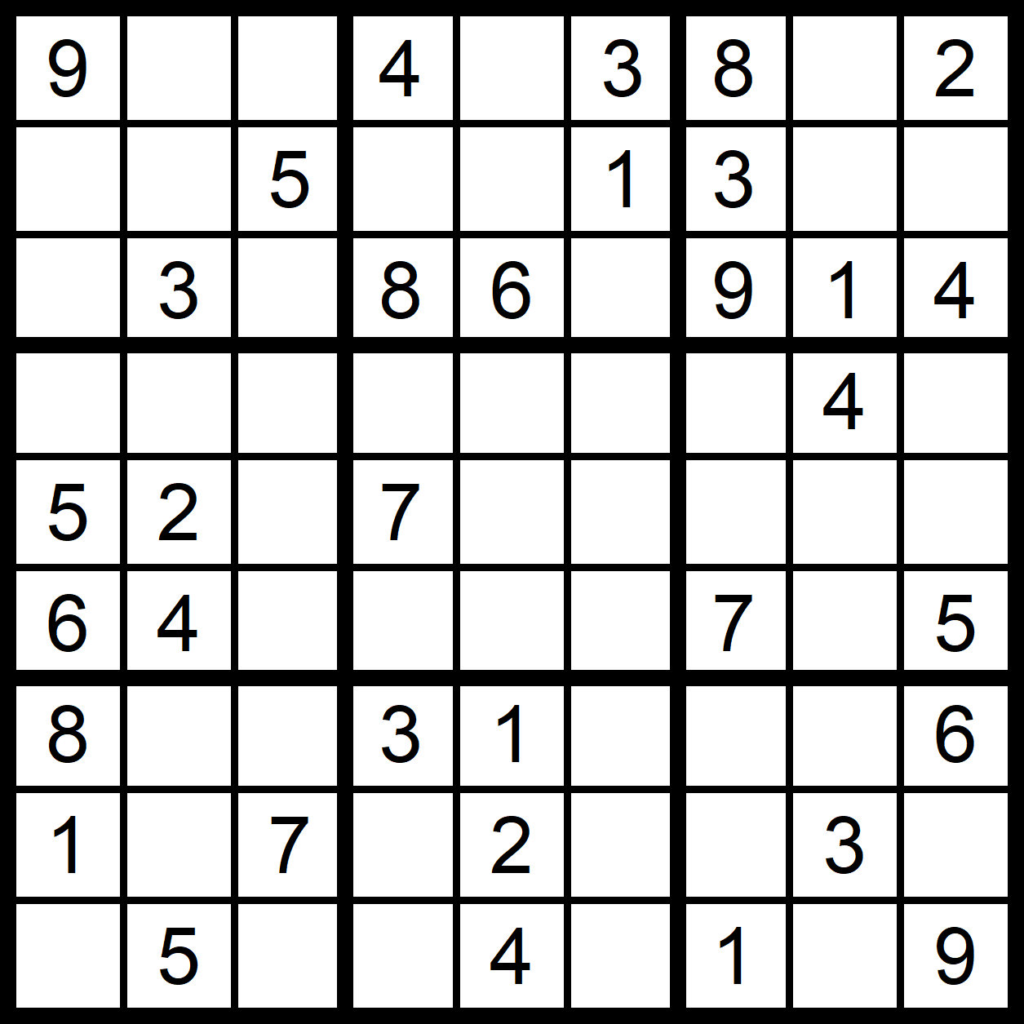

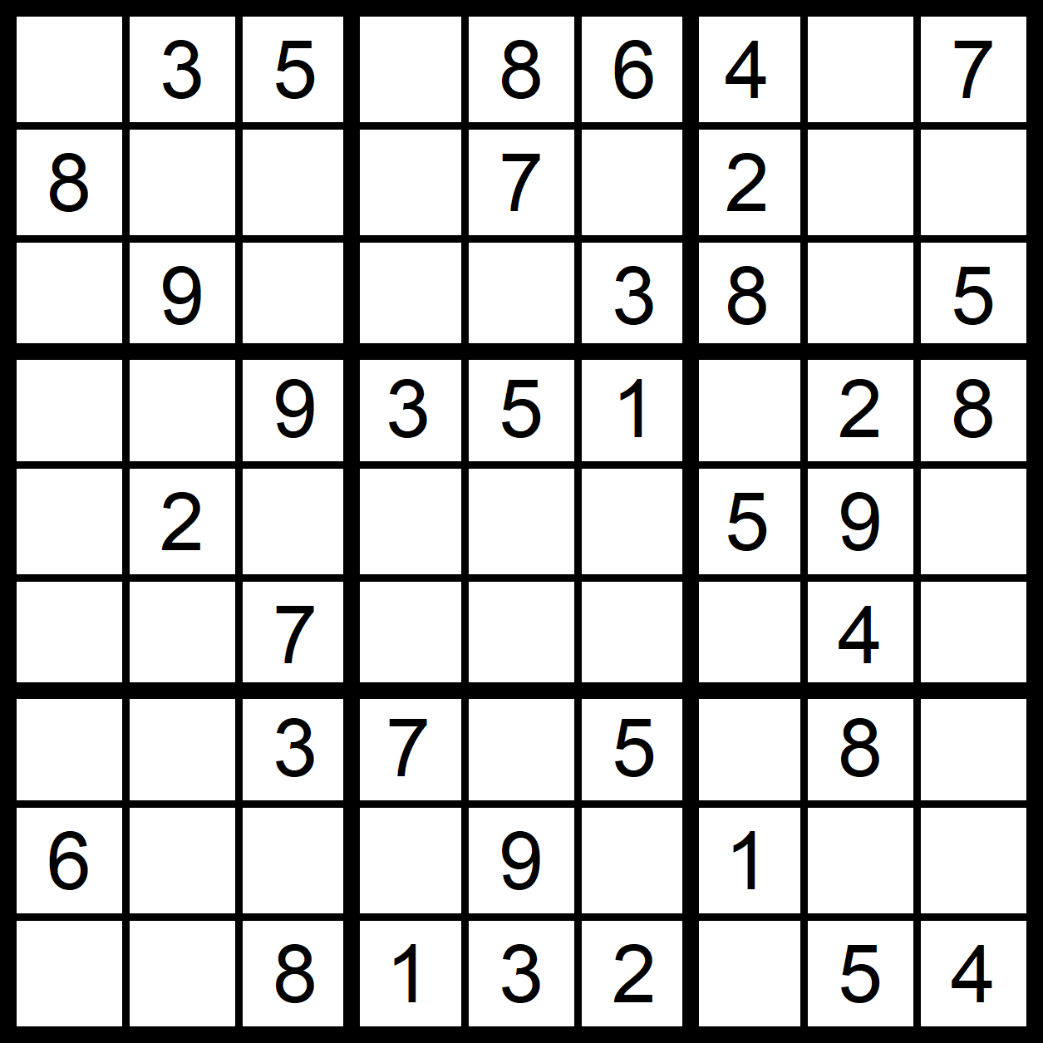

Design a Poster
Plan it in rough first, then draw it properly in the frame.
It’s Maths Week this month. Create a poster advertising a Maths Week event at your school. It could be a competition, a quiz, a fancy-dress event or even a party. You can also invent an entirely different event.
Design a poster that gets people excited. Remember that a poster has two jobs at once: it must tell people what they need to know and make them want to come.
Before you start, decide on the four things below.
– The one image someone will see from across the room
– Your headline, in six words or fewer
– The three facts somebody attending absolutely needs to know – where, when and what will happen
– Why your event will make maths exciting

Planning Box

Design a Poster

Spot the Difference
Ten things have changed in this mushroom scene and someone isn’t happy! Can you find them all?
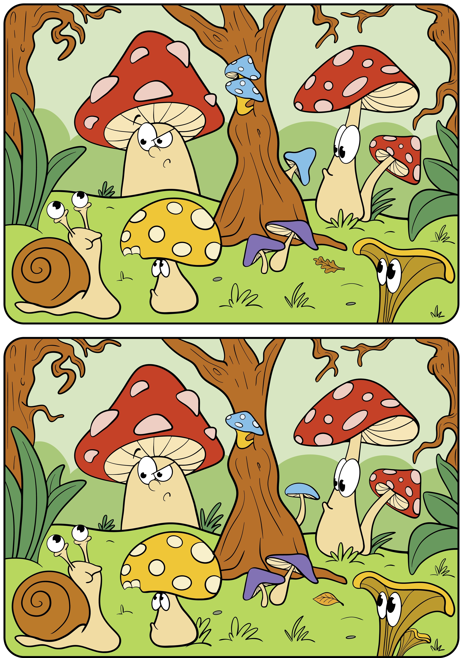

Answers
Fill in the Blanks  1. lid  2. scooped  3. face  4. smiling  5. light  6. holes  7. devil  8. turnip  9. enjoy | All the Mistakes  1. passengers  2. driver  3. cameras  4. steer  5. driverless  6. Switzerland  7. join  8. hoped  9. driving  10. WeRide | Word Workout  1. zombie  2. critters  3. roughly  4. iron  5. marrow  6. inspired  7. region  8. flinches  9. distinctive  10. verified  11. ordinary  12. adolescent  13. traditionally  14. collapsing

What’s in the News? Spot the Difference (Pack)
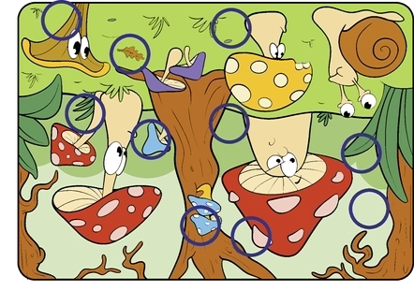
1. A strangler fig
2. Margays
3. Austin
4. China
5. St Lassara’s National School
6. A honey fungus
7. The noble false widow
8. An ancient wasp

Know Your Sport Word Search (magazine)
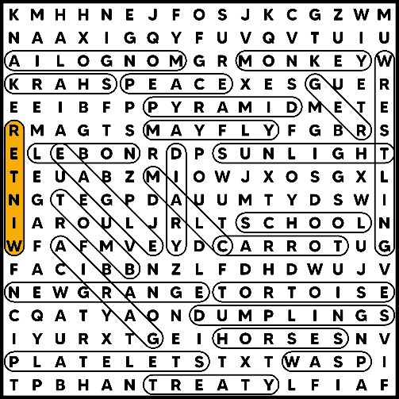
1. Manchester City
2. Argentina
3. Real Betis
4. 80,000
5. Six
6. Aryna Sabalenka
7. Six
8. 45

Answers
Quiz 24  1. Jonathan  2. His Hallowe’en goodie bag  3. Sputnik 1  4. Swifties  5. No  6. Around five litres  7. A clot  8. Edward Bear  9. The Religious Society of Friends  10. University College Dublin, Atlantic Technological University and South East Technological University  11. Eggmühl, Germany  12. Around 1832 | Quiz 24 continued  13. Fencing  14. Every girls’ school in Swat to close  15. For defending every child’s right to an education  16. Dogs or puppies  17. hello@newsflash.ie  18. The Altai Mountains  19. Naadam  20. Balaeniceps rex  21. Around 5,300 years ago  22. League Two  23. 6–2  24. 8.90 metres

Crack the Joke (page 17)
How do you put a baby astronaut to sleep? You rocket, of course!

All Mixed Up (page 16)
Wrestling, mayfly, tortoise, ger, whale, Newgrange, diary, carrot, wasp and shark.

Sudoku
