THE PRIMARY PLANET
Curriculum Planner
Cuntas Míosúil
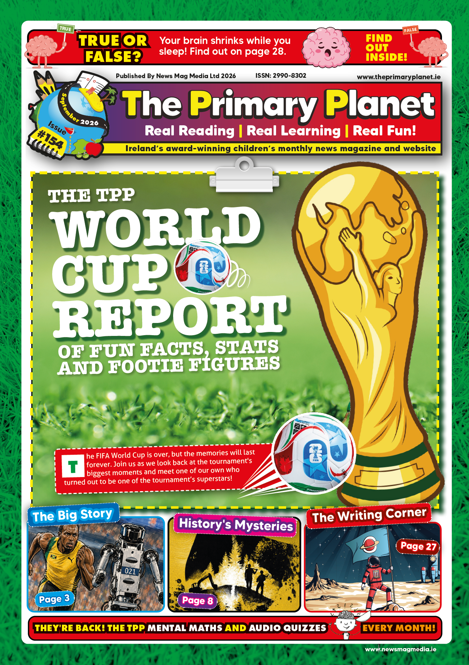
September 2026
Issue #154
Stage 4 – Fifth and Sixth Classes

WHOLE-ISSUE LANGUAGE LINK
Curriculum area / subject | Language – English
Strand / Strand Unit | Reading; Oral language
Issue focus | Every section of Issue 154 – news reports, history, geography, science, art, music, sport and biography.
Relevant Stage 4 learning outcomes | • Read, understand and respond to a wide range of texts across the curriculum, identifying key points, supporting detail and the order in which events happen.  • Discuss and justify opinions on texts in a range of genres, considering the purpose of the writer and the effect of particular choices of language.  • Acquire, discuss and use new subject-specific vocabulary encountered in reading across the curriculum.
Integration | The Resource Pack activities Fill in the Blanks, All the Mistakes, Word Workout, Quiz 32, What’s in the News and Know Your Sport all draw directly on these outcomes.
THE BIG STORY – NOT SO QUICK, ROBOTS! (page 3)
Curriculum area / subject | STEM Education – Science, Technology and Engineering; Wellbeing – SPHE
Strand / Strand Unit | Nature of STEM; Technology. Wellbeing: Emotional and relational education / Resilience.
Issue focus | Humanoid robots at the World Humanoid Robot Games, the 9.39-second 100m run, the limits of robots, a timeline of robotics from 1961 to 2026, and Kate O’Connor’s European heptathlon gold.
Relevant Stage 4 learning outcomes | • Explore and discuss how science, technology and engineering have developed over time and how they shape society, weighing up benefits and limitations.  • Investigate how inputs, processes and outputs allow digital and non-digital technologies to function.  • Reflect on the link between effort, practice and improvement, and on the personal qualities that support perseverance.
Integration | Language – argument and discussion: are robots about to take over? Mathematics – comparing times to two decimal places.
NATIONAL NEWS (pages 4 and 5)
Curriculum area / subject | Language – English; Social and Environmental Education – History and Geography
Strand / Strand Unit | Reading; Oral language. SEE: The island of Ireland; Environment and sustainable living.
Issue focus | El Galeón Andalucía and the Spanish Armada, Glen Hansard, the redesigned Irish passport, Ireland’s EU Presidency, the record-breaking summer, and the new e-scooter rules.
Relevant Stage 4 learning outcomes | • Identify key points of information and supporting detail in current-affairs texts and discuss the writer’s purpose.  • Examine significant events and developments in the story of Ireland and consider their effects on people’s lives.  • Investigate how weather and climate patterns affect people, places and the environment, using evidence and records.
Integration | Wellbeing – personal safety and risk, through the e-scooter rules. Mathematics – reading and comparing temperature records.
INTERNATIONAL NEWS (pages 6 and 7)
Curriculum area / subject | Social and Environmental Education – Geography; STEM Education – Science
Strand / Strand Unit | Europe and the wider world / People and places; Environment and sustainable living. Science: Living things.
Issue focus | The Greenlink interconnector and the Dobby memorial in Wales, the newly confirmed Likweli monkey in the Democratic Republic of the Congo, and the marble-waste site turned tourist attraction in Rajasthan.
Relevant Stage 4 learning outcomes | • Locate and describe places, landmarks and physical features in Europe and the wider world.  • Examine how people use, change and manage environments, and evaluate the effects of those decisions.  • Classify living things and investigate how they are adapted to survive in their habitats.
Integration | Language – explanation and opinion writing. Wellbeing – valuing places that matter to communities.
HISTORY’S MYSTERIES – THE OAK ISLAND MONEY PIT (page 8)
Curriculum area / subject | Social and Environmental Education – History
Strand / Strand Unit | Europe and the wider world; Working as a historian.
Issue focus | The 1795 discovery, the wooden platforms, the flooding of the pit, the carved stone, coconut fibre, and the competing explanations for what lies beneath the island.
Relevant Stage 4 learning outcomes | • Examine and evaluate a range of historical evidence, distinguishing between fact, opinion and interpretation.  • Recognise that historical events can be explained in more than one way and that evidence may be incomplete or contested.
Integration | Arts Education – Drama: the Oak Island Inquiry lesson in the Resource Pack. Language – forming and defending an argument.
OUR ISLAND’S HISTORY – TRUCE & TREATY (page 9)
Curriculum area / subject | Social and Environmental Education – History
Strand / Strand Unit | The island of Ireland; Continuity and change over time.
Issue focus | The July 1921 truce, the London talks, the terms of the Anglo-Irish Treaty, the retained naval bases at Lough Swilly, Berehaven and Queenstown, and the decision facing the Irish delegation.
Relevant Stage 4 learning outcomes | • Investigate significant events, people and developments in the history of Ireland and explain their importance.  • Identify causes and consequences, and recognise that people in the past made decisions with limited choices and under pressure.
Integration | Language – debate and persuasive talk: should the delegation have signed? Geography – locating the treaty ports.
MEDIA MATTERS – MEET THE TEAM (pages 10 and 11)
Curriculum area / subject | Language – English; Wellbeing – SPHE
Strand / Strand Unit | Oral language; Reading. Wellbeing: Safety and protection / Digital wellbeing.
Issue focus | The work of Coimisiún na Meán, four staff profiles, media literacy, online safety and the regulation of media in Ireland.
Relevant Stage 4 learning outcomes | • Evaluate information from a range of media, considering purpose, reliability and point of view.  • Discuss the choices people make online and identify strategies and sources of support that help keep them safe.
Integration | SEE – how public bodies work. Language – interview as a form of writing, and questions worth asking.
PLANET ART – THE OBLITERATION ROOM (page 12)
Curriculum area / subject | Arts Education – Art
Strand / Strand Unit | Responding and connecting; Exploring and creating.
Issue focus | Yayoi Kusama, interactive installation as an art form, polka dots, colour, pattern, scale and the audience’s part in completing the work.
Relevant Stage 4 learning outcomes | • Respond to artworks from Ireland and the wider world, describing the use and effect of colour, line, shape, pattern, form and space.  • Explore and identify techniques and characteristics associated with different media, styles and contexts.  • Plan and create original work, making decisions about materials, colour and composition.
Integration | The Joining the Dots lesson in the Resource Pack. Mathematics – shape, space and tessellation.
WWW NEWS (page 13)
Curriculum area / subject | Language – English; Arts Education – Art
Strand / Strand Unit | Oral language; Reading. Art: Responding and connecting.
Issue focus | The Turnip Prize, the tissue-box game and the rehoming of Ella’s puppies.
Relevant Stage 4 learning outcomes | • Listen and respond to a range of texts, giving and justifying personal opinions.  • Discuss what makes a piece of work art, recognising that people hold different views.
Integration | Wellbeing – care for animals. Language – humour, tone and register in news writing.
PLANET FARMING (page 14)
Curriculum area / subject | Social and Environmental Education – Geography; STEM Education – Science
Strand / Strand Unit | My locality / People and places; Environment and sustainable living. Science: Living things.
Issue focus | The farming year, calving, silage, hay, slurry, drainage and fencing, and the seasonal rhythm of work on an Irish farm.
Relevant Stage 4 learning outcomes | • Examine economic activities in the locality, including food and farming, and explore how they have changed over time.  • Investigate how living things are cared for and managed, and the conditions they need to thrive.
Integration | Mathematics – measures and time. Language – occupational vocabulary and recount.
PLANET MOTORS – BYD YANGWANG U9 XTREME (page 15)
Curriculum area / subject | STEM Education – Science, Technology and Engineering; Mathematics
Strand / Strand Unit | Energy and forces; Technology. Mathematics: Measures / Number.
Issue focus | Electric propulsion, acceleration, top speed, the 1,200-volt system, suspension, and the Nürburgring lap time.
Relevant Stage 4 learning outcomes | • Investigate how forces cause objects to move, stop and change speed or direction.  • Identify and distinguish between renewable and non-renewable sources of energy and explore how energy is stored and transformed.  • Compare, approximate and calculate using measures of speed, time and distance.
Integration | Language – technical explanation. SEE – manufacturing and trade.
THE TPP WORLD CUP REPORT (pages 16 and 17)
Curriculum area / subject | STEM Education – Mathematics; Wellbeing – Physical Education
Strand / Strand Unit | Data and chance; Number. Wellbeing: Movement competence; Participation.
Issue focus | Tournament statistics, records and firsts, and the story of Roberto ‘Pico’ Lopes, the Dublin footballer who captained Cape Verde.
Relevant Stage 4 learning outcomes | • Collect, represent, interpret and compare data, drawing conclusions and asking further questions of the data.  • Reflect on the personal and social value of sport and physical activity, and on what participation means to players and supporters.
Integration | SEE – Geography: locating the host nations and competing countries. Language – sports report as a genre.
PLANET PLACES – PETRA, JORDAN (page 18)
Curriculum area / subject | Social and Environmental Education – Geography and History
Strand / Strand Unit | Europe and the wider world / People and places.
Issue focus | Petra as an archaeological site, the Nabataeans, rose-red sandstone, the naming of Raqmu and Petra, tourism and life in Jordan today.
Relevant Stage 4 learning outcomes | • Describe and compare major physical and human features of places in Ireland, Europe and the wider world.  • Investigate how people in the past shaped the places they lived in, using archaeological and written evidence.
Integration | Arts Education – Art: colour, rock and light. Language – travel writing and description.
OUR PLACE IN SPACE – THE EAGLE HAS LANDED (page 19)
Curriculum area / subject | Social and Environmental Education – History; STEM Education – Science, Technology and Engineering
Strand / Strand Unit | Europe and the wider world; Continuity and change over time. STEM: Nature of STEM.
Issue focus | Yuri Gagarin, the Space Race, Kennedy’s challenge, the Apollo programme, Columbia and Eagle, and the first Moon landing.
Relevant Stage 4 learning outcomes | • Sequence significant events on a timeline and explain their causes and consequences.  • Explore how scientific and technological developments have changed over time and the part collaboration plays in them.
Integration | The Mission to the Moon lesson and Apollo 11 Mission Cards in the Resource Pack. Language – recount and eyewitness accounts.
ANIMAL SOS – THE KĀKĀPŌ (page 20)
Curriculum area / subject | STEM Education – Science; Social and Environmental Education – Geography
Strand / Strand Unit | Living things. SEE: Environment and sustainable living.
Issue focus | The kākāpō’s Māori name, its booming mating call, flightlessness and climbing, the collapse of its population, and the Recovery Plan.
Relevant Stage 4 learning outcomes | • Classify living things and investigate the adaptations that allow them to survive in their habitats.  • Explore human impact on habitats and evaluate the actions taken to protect species at risk.
Integration | Language – report writing and persuasive writing. SEE – New Zealand and Māori language and culture.
PLANET MATHS (page 21)
Curriculum area / subject | STEM Education – Mathematics
Strand / Strand Unit | Number / Sets and operations; Measures / Time; Algebra.
Issue focus | Crack the Quote multiplication code, and Maths Story #154, which covers time zones, percentages, fractions, averages and money.
Relevant Stage 4 learning outcomes | • Understand and apply the four operations flexibly and recognise the relationships between them.  • Solve problems involving time, including time zones, elapsed time and timetables.  • Calculate and interpret averages, percentages and fractions of quantities in real-life contexts.
Integration | Language – reading a word problem closely and identifying what is being asked.
PLANET STEM (page 22)
Curriculum area / subject | STEM Education – Science, Technology and Engineering
Strand / Strand Unit | Living things; Technology; Engineering; Nature of STEM.
Issue focus | Cyborg cockroaches and insect spiracles, the ISS air leak and its planned retirement, and the MIT finding that rice seeds may respond to the sound of rain.
Relevant Stage 4 learning outcomes | • Investigate how living things are structured and how they take in what they need to survive.  • Consider user needs, risks and limitations when examining a design solution to a real problem.  • Explore how scientific claims are tested, and recognise when more evidence is needed before a conclusion can be drawn.
Integration | Language – reading science news critically. Wellbeing – search and rescue, and technology that helps people.
COUNTY BY COUNTY (page 23)
Curriculum area / subject | Social and Environmental Education – Geography
Strand / Strand Unit | The island of Ireland / People and places.
Issue focus | A recap of the nine counties visited so far, landmarks, place names and nicknames, and a class vote on where the tour goes next.
Relevant Stage 4 learning outcomes | • Demonstrate familiarity with the location, names and significant landmarks of counties across the island of Ireland.  • Use maps, atlases and digital tools to locate places and describe their features.
Integration | Wellbeing – democratic decision-making through the class vote. Language – Irish place names and their meanings.
PLANET FOOD – SWEET (POTATO) BROWNIES (page 24)
Curriculum area / subject | Wellbeing – SPHE; STEM Education – Mathematics
Strand / Strand Unit | Health education / Healthy living. Mathematics: Measures / Number.
Issue focus | The origins of the brownie, and a recipe using sweet potato, oats and 16 portions.
Relevant Stage 4 learning outcomes | • Explore what makes a balanced diet and make informed choices about food.  • Measure and calculate using weight, capacity and time, including scaling a quantity up or down.
Integration | Language – procedural writing. SEE – food origins and food history.
PLANET MUSIC – CLASSICAL MUSIC TODAY (page 25)
Curriculum area / subject | Arts Education – Music
Strand / Strand Unit | Responding and connecting; Listening.
Issue focus | Where classical music turns up in films, games, adverts and online, and what the term ‘classical music’ actually covers.
Relevant Stage 4 learning outcomes | • Listen and respond to a broad range of music, describing what is heard using appropriate musical vocabulary.  • Discuss how music is used in different settings and why particular music suits a particular purpose.
Integration | Language – opinion and justification. Digital media – how soundtracks shape what we feel.
PLANET BOOKS (page 26)
Curriculum area / subject | Language – English
Strand / Strand Unit | Reading; Writing.
Issue focus | Pupil book reviews, the TPP Library, and the invitation for readers to send in their own reviews.
Relevant Stage 4 learning outcomes | • Read widely for pleasure and share responses to books with others.  • Write for a real audience and purpose, choosing detail that will help a reader decide whether to read the book.
Integration | The book review template in the Resource Pack. Oral language – recommending a book to the class.
THE WRITING CORNER (page 27)
Curriculum area / subject | Language – English
Strand / Strand Unit | Writing.
Issue focus | Advice on showing rather than telling, avoiding weak endings, and treating the first draft as a draft.
Relevant Stage 4 learning outcomes | • Draft, revise and edit writing, making deliberate choices about word, sentence and structure to achieve an effect.  • Write in a range of genres for different audiences and purposes.
Integration | Reading – noticing the same techniques at work in the texts elsewhere in the issue.
PLANET YOU – YOUR BRAIN LOVES MISTAKES (page 28)
Curriculum area / subject | Wellbeing – SPHE; STEM Education – Science
Strand / Strand Unit | Emotional and relational education / Resilience. Science: Living things – the human body.
Issue focus | Neurons and connections, the brain’s ‘oops’ signal, and why getting things wrong is part of learning.
Relevant Stage 4 learning outcomes | • Recognise the link between effort, mistakes and improvement, and demonstrate strategies that support resilience.  • Investigate the structure and function of the human body and how its systems work together.
Integration | Language – explanation. Whole-school – feedback, assessment and how the class talks about getting things wrong.
PLANET SPORT, PLANET SOCCER AND OUR SUMMER HEROES (pages 29 to 32)
Curriculum area / subject | Wellbeing – Physical Education; STEM Education – Mathematics
Strand / Strand Unit | Participation; Movement competence. Mathematics: Data and chance; Number.
Issue focus | Ireland’s rowing medals, the Premier League transfer window, Katie McCabe’s move, and nine Irish medals at the European Championships.
Relevant Stage 4 learning outcomes | • Reflect on the value of participation, training and setbacks in a sporting journey.  • Collect, organise and interpret data, and compare quantities including large sums of money.
Integration | SEE – Geography: locating the events. Language – reading and writing sports reports.

